

**JAIPURIA INSTITUTE OF MANAGEMENT, NOIDA**

**PGDM / PGDM (M) / PGDM (SM)**

**SECOND TRIMESTER (Batch 2024-26)**

**END TERM EXAMINATIONS, JANUARY 2025**

**MAIN EXAM**

|  |  |  |  |
| --- | --- | --- | --- |
| Course Name | **OPERATIONS MANAGEMENT** | Course Code | **20502** |
| Max. Time | **2 hours** | Max. Marks | **40 MM** |

INSTRUCTIONS:

1. Attempt all Questions from Part-A and Part B.
2. This is a closed book examination.
3. Only calculators allowed. Use of mobile and any other electronic device prohibited.
4. Answers should be rich in content, pointwise. Avoid unnecessarily long answers.

**PART A**

Case: Beta Plastics India Ltd.

Beta Plastics India Ltd. specializes in the design and manufacture of plastic containers primarily for kitchen and household use. Its products are sold through merchandise retailers and are recognized for high quality. Beta also has an active R&D group that was continuously working to develop new plastic materials and new product designs. Beta is an industry leader and is aggressively looking to increase brand recognition and market share.

Beta’s R&D group has recently developed a new plastic material that tolerates rapid changes in temperature from heating to deep cooling. The material could be used to make containers for kitchen use that could immediately be moved from oven to the refrigerator. Unlike glass containers with this capability, the plastic containers would not break and chip.

**Q1)**

Beta’s General Manager (Operations) and his team has to design the assembly line for the new plastic containers. General Manager (Operations) wants to achieve the target production of 60 containers per hour. The Table 1 gives the necessary information:

**Table1:**

|  |  |  |
| --- | --- | --- |
| **Task** | **Immediate Predecessor** | **Task Time (seconds)** |
| A | None | 50 |
| B | A | 5 |
| C | B | 25 |
| D | C | 15 |
| E | D | 12 |
| F | D | 10 |
| G | D | 15 |
| H | E,F,G | 18 |
| I | H | 15 |

1. Design and balance an assembly line with fewest number of workstations that will achieve the production target without violating the precedence requirements.
2. Determine the efficiency of the line.

*(For Prioritizing Tasks for assignment to work stations use the following rule: Primary Rule- Prioritize task in order of longest task time; Second Rule- To be invoked only when there is a ties in the Primary Rule. Prioritize task in order of largest number of following tasks)*

**(Marks 4 + 2)**

**Q2)**

Eight months after the launch of new plastic containers, the Sales Deptt. at Beta has collected the following demand data for **past eight months**, given in Table 2

**Table 2:**

|  |  |
| --- | --- |
| **Month** | **Demand for New Plastic Containers (000)** |
| **1** | 7 |
| **2** | 6 |
| **3** | 10 |
| **4** | 2 |
| **5** | 1 |
| **6** | 9 |
| **7** | 12 |
| **8** | 4 |
| **9** |  |

1. Compute a 3 month weighted moving average forecast for **months 4 to 9**. Assign weights of 0.55, 0.33 & 0.12 to the months in sequence starting with the most recent months i.e. *0.55 for the latest / most recent month and 0.12 for the oldest week*). Also, compute the forecast accuracy using MAD.
2. Briefly discuss the tradeoff involved in selecting longer or shorter averaging period in moving average demand forecasting methods.

**(Marks 4 + 2)**

**Q3)**

Beta uses continuous review inventory management system for procurement of critical spare parts required for production machinery. One of the such spare part SKU - X has the following characteristics – Demand 64 units per week (Plant works for 52 weeks per year). Ordering costs = INR 50/order; Holding rate= 20%; Unit cost of SKU-X = INR 65.

1. Determine the Economic Order Quantity (EOQ) for SKU-X.
2. Also determine the total annual inventory related costs (annual ordering costs and annual inventory holding costs) for SKU-X.

**(Marks 3 + 3)**

**Q4)**

Based on the consistent growth, loyal domestic customer base and growing potential of exports, Beta has decided to scale up production to transform itself into a global brand. Beta plan to increase production and set up a new production plant. Discuss various operations strategy decisions which Beta’s General Manager (Operations) need to consider while setting up the new production plant.

**(Marks 6)**

**Q5)**

The executives at Beta have shortlisted three potential locations in the states of Punjab, Uttar Pradesh and Gujarat for setting up new production plant. In-depth analysis of these locations was done based on the defined criteria. Same is given in Table 3.

**Table 3**

|  |  |  |  |  |
| --- | --- | --- | --- | --- |
| **Criteria/Factors** | **Weight** | **Score (scale of 10)** | | |
|  |  | **Punjab** | **Uttar Pradesh** | **Gujarat** |
| Proximity to raw material | 25% | 8 | 6 | 9 |
| Proximity to railway station | 20% | 9 | 7 | 10 |
| Vendor proximity | 15% | 8 | 7 | 9 |
| Transportation services | 20% | 8 | 8 | 9 |
| Labour availability | 10% | 9 | 6 | 9 |
| Utilities and infrastructure | 10% | 8 | 7 | 10 |

1. Recommend suitable location from the in the states of Punjab, Uttar Pradesh and Gujarat for setting up new production facility of Beta Plastics India Ltd *(by analyzing the data given in Table 3 using appropriate quantitative method for selecting plant location).*
2. Compare the location factors for selecting suitable location for setting up a new production plant for a plastic containers manufacturing company such as Beta Plastics India Ltd. with a steel manufacturing company setting up a new steel plant.

**(Marks 4+2)**

**PART -B**

**Q6)**

Just Like Home Restaurant is a family restaurant offering regular dining as well as fast food. It has asked you to analyse some of its processes. One of the operations process is making a single scoop ice cream cone. Cones can be ordered by a server (for table service) or by a customer (for takeout). Process Chart is given below:

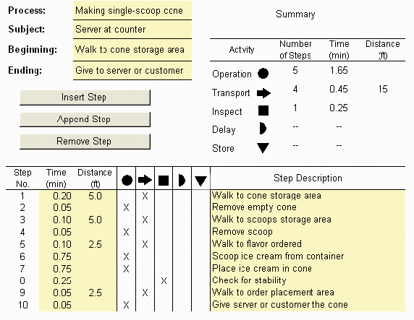

Analyse the above process – “Making a single scoop ice cream cone”, examine the steps mentioned above and thereafter identify & recommend **the possible improvements in this process**?

**(Marks 4)**

**Q7)**

1. Just Like Home Restaurant (mentioned above) wishes to implement Total Quality Management and related quality management programs to enhance customer satisfaction. As a Quality Consultant, discuss TQM principles and recommend best practices which should be implemented by Just Like Home Restaurant for improving quality of it’s services.
2. Discuss ABC inventory classification which may be employed by a manufacturing or a service organization such as Just Like Home Restaurant for better inventory management.

**(Marks 3+3)**