JAIPURIA INSTITUTE OF MANAGEMENT, NOIDA
PGDM / PGDM (M) / PGDM (SM)
FIFTH TRIMESTER (Batch 2022-24)
END TERM EXAMINATIONS, JANUARY 2024

Course Name | Materials and Inventory Management | Course Code | 20257
Max. Time | 2 hours | Max. Marks | 40 MM

INSTRUCTIONS:
- All questions are compulsory.
- Use of simple/scientific calculators is allowed

Q.1. (a) Discuss the principle on which ABC analysis is based. (3 Marks)
(b) Classify the items based on ABC analysis for the given data. (7 Marks)

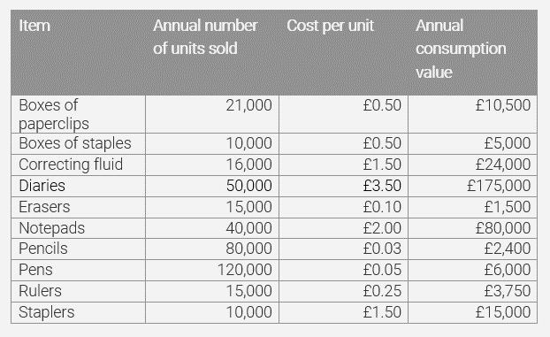
Q.2. A plant manager must determine the lot size of a product that has a steady demand of 30 units per day. The production rate is 190 units per day, annual demand is 10,500 units, set up cost for a production run is 200.00 and holding cost is 0.21 per unit. Plant operates for 350 days per year. With this information calculate: (2.5*4 = 10 Marks)
a) Economic production lot size
b) Total annual cost
c) Time between orders (TBO) or cycle length
d) Production time per lot

Q.3. Use graphical method to determine the time needed to process the following jobs on the machines shown below. Also, determine the total processing time to complete the jobs.
(10 Marks)
Job 1 | Sequence | A | B | C | D | E
 | Processing time (hrs) | 3 | 4 | 2 | 6 | 2
Job 2 | Sequence | B | C | A | D | E
 | Processing time (hrs) | 5 | 4 | 3 | 2 | 6

Q.4. A dealer has 47 units of desktop in his stock. If in case he needs to order more desktops, it takes 2 weeks to receives them after placing an order. Also, he can place an order for a fixed quantity (lot size) of 200 units. Based on the orders at hand and forecasted demand he has generated the gross requirement of desktops for next 8 weeks, which is as follows:
(10 Marks)
Week | 1 | 2 | 3 | 4 | 5 | 6 | 7 | 8
Gross requirement | 150 | - | - | 120 | - | 150 | 120 | -

Propose a material requirement plan for the desktops, assuming that dealer need to maintain a minimum stock of 50 units to meet any uncertain demand.

