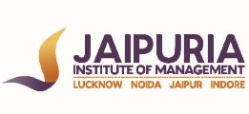

JAIPURIA INSTITUTE OF MANAGEMENT, NOIDA
PGDM / PGDM (M) / PGDM (SM)
IV TRIMESTER (Batch 2021-23)
END TERM EXAMINATION, NOVEMBER 2022

Course Name | Industrial Relations and Labour Laws | Course Code | 20323
Max. Time | 2 hours | Max. Marks | 40 MM

INSTRUCTIONS: Attempt all questions. Each question is of 10 marks.

Q. 1 A climate of unemployment, and the burgeoning trade union movement, propelled state interventions, introduction of new Industrial Relations code 2019. Against this backdrop, the Industrial Disputes Act 1947 (the ID Act) was enacted to provide for investigation and settlement of industrial disputes.
Critically examine the legal framework for Industrial dispute resolution in India. In what specific ways does the existing system inhibit collective Bargaining. (10)

Q 2. A Multinational Company specialised in food processing has been operating in India for about 3 decades. The Company has recently decided to expand its production. It was decided to shift the factory to a new location about 20 kms. away from its present site. As the workers transferred to the new site were living in town, the union demanded an increase of Rs. 6000/- per month in the salary, but the Company offered to give Rs. 2500/- only to cover the transport cost. When the plant was being shifted to the new site, negotiations went on uninterrupted between the Management and the Union on this issue. However both the parties could not come to a settlement even after 6 months. The Management was firm on their decision even though the union indicated some flexibility. The Union refused to compromise fully on the issue. They adopted go slow tactics to pressurize the Management. The production went down drastically, but still the Management was firm on their stand. In the meanwhile the Management charge-sheeted some of the Trade Union leaders and suspended them pending enquiry.
Analyse the case given above and elucidate the problem and causes. As a General Manager – HR of this Company how would you resolve the problem ? (10)

Q.3 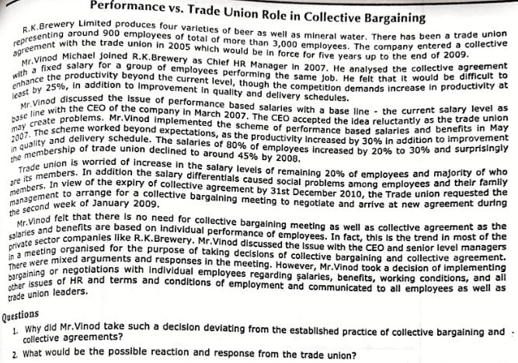 (5+5)

Q.4 Critically analyze the recent labour Codes on Industrial relations and Social security. Highlight the key changes that these two codes will bring in the ways of functioning of Industries. (10)

